Program for (10 days 9 nights) in Egypt

(Cairo -Aswan-Luxor-red sea hurghada -Cairo)

Day no 1 Cairo

Meet and assist at Cairo airport and drive to the hotel (5 stars’ hotel at pyramids location)

Depend about the arrival time and chick in the hotel and overnight at the hotel

Special meet and assist at Cairo airport and at the hotel when arrival.

Overnight at hotel

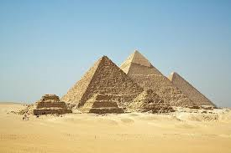

Day no 2 Cairo

Breakfast and drive to the (Cairo museum, citadel of salah Elden, the alabaster mosque of Mohamed Aly  in old Cairo ,

And drive to the restaurant for lunch and drive to coffee shop for hot drink and drive to the hotel for rest

At 8pm drive to good restaurant for grill dinner and coffee shop and drive to hotel for over night

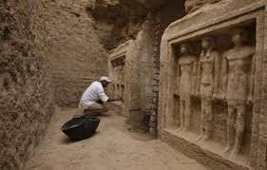

Day no 3 Cairo

Breakfast and drive to the pyramids and visit the 3 pyramids and Sakkara and Memphis and visit the statue of Ramses 2

The alabaster sphinx, the stepped pyramid the sterapeum discovered in  1851 ,the tomb of Aips or sacred buiTs the mastaba of TI and pathorep.

And free time in bazar's and drive to restaurant for lunch and drive to hotel for rest

At 8 pm drive to Nile cruse for 3 hours in the Nile for enjoy open buffet dinner and dancing and songs with Egyptian oriental dance accompanied with oriental music music and songs and dinner and drive to the hotel over night at the hotel in Cairo.

Day no 4

Breakfast early morning at 5 am and drive to airport to fly to Aswan

Arrival at Aswan airport and meet by our company tour guide and our driver and drive to the high dam and visit the unfinished obelisk and visit edfu temple and visit and drive the the cruse to lunch open buffet and dinner o/b in Aswan

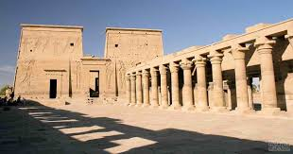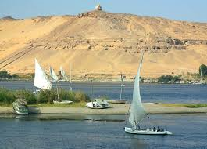

Day no 5 aswan- luxor

Breakfast and drive to visit the ISIS temple and back to the cruse for lunch and drive to visit komombo temple .sailing to edfu temple .after noon tea dinner O/B and overnight in EDFU on the cruse

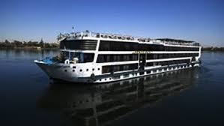

Day no 6 luxor

Breakfast and sailing to Esna and have lunch on board. sailing to Luxor. afternoon tea at coffee shop located on the Nile drive to the cruse and dinner on board and overnight at boat at Luxor city

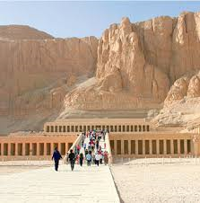

day no 7 luxor

breakfast and start drive to visit the west bank (valley of kings) Hatshepsut temple. colossi of Memnon and lunch O/B

and free at leisure in Luxor Nile side and visit the karnak temple and Luxor temple in Luxor (optional )and (balloon fly ) optional if need

dinner O/b overnight in Luxor.

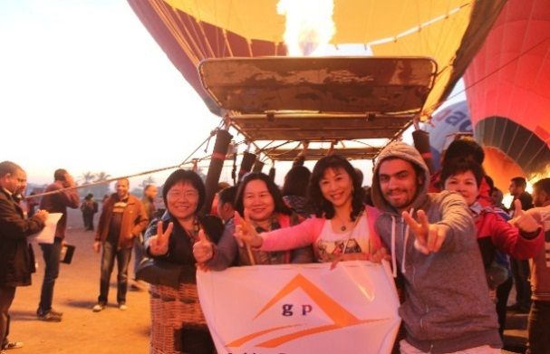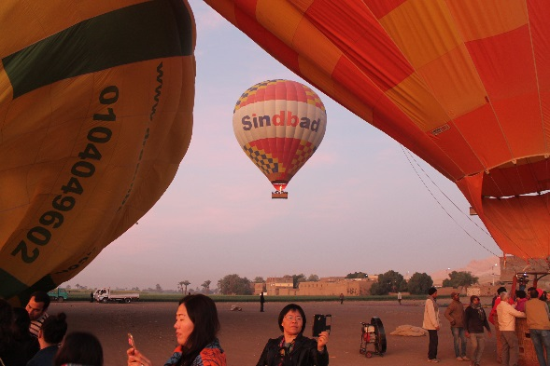

Day no 8 red sea hurghada

Breakfast and drive to red sea hurghada resort for enjoy the best beach in red sea

Lunch and dinner included,

Overnight in red sea

DAY NO 9 RED SEA HURGHADA

Breakfast and enjoy red sea

Lunch and dinner included

Day no 10 red sea hurghada

Enjoy the beach

Drive to Cairo for fly back home

We offer

Bottled water every day free

Hot drink every day free

Hot drink at the bus free

Meet and assist at airport free

Visa at airport when arrival in Cairo

Luggage assist by our staff

We hope can meet your accept

                                                                                                            Thanks

Zamzam tours

      Hazem abou bakr nagi